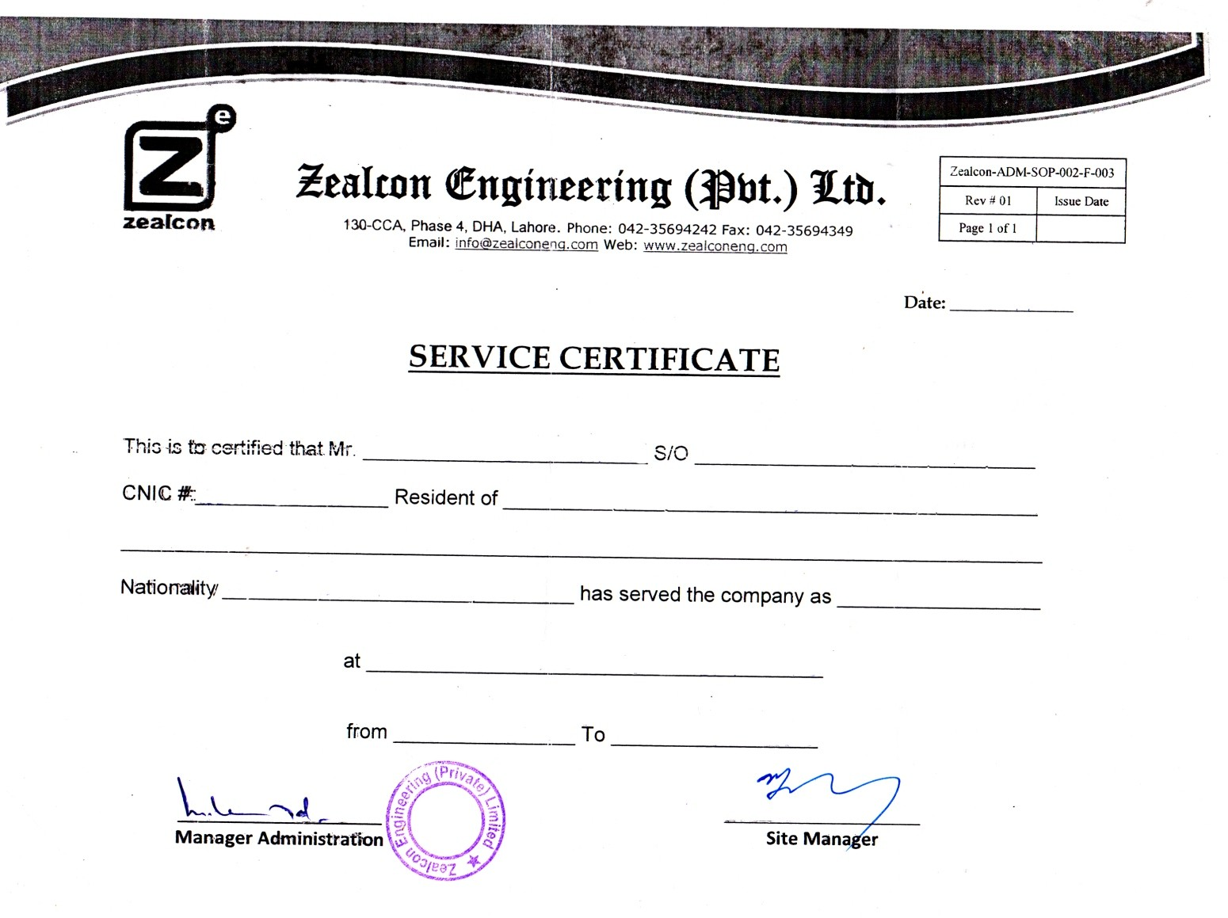

**<To2>**

**<To2>**

**<Name> <fname>**

**<CNIC> District Multan**

**Pakistani <Designation>**

**Mehar Gas Development Project**

**<From2> <To2>**